# Methodology

This section of the document will display the setup process of Kickstart, a remote network Operating System through the use and configuration of a blank CentOS 7 virtual machine and the configuration, installation and setup of services such as Kickstart, DHCP, NFS and Go!.

# Virtual machine configuration

Beginning with the virtual machine configuration, in this section I will simply be setting up a blank virtual machine, this will be used later as my kickstart server where I will install CentOS remotely.

1. 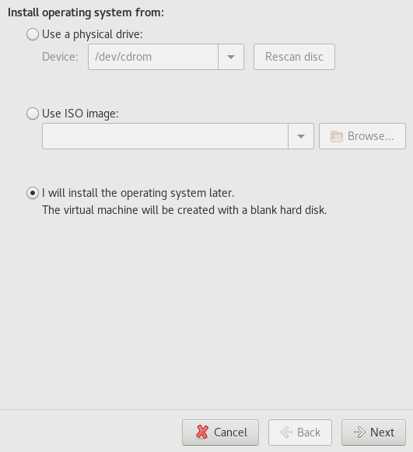

Figure 1 Selected install operating system later

1. 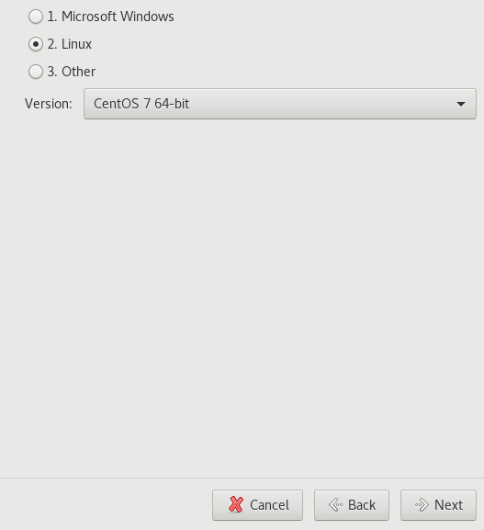

CentOS 7 as chosen version of Linux

1. 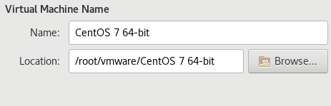

Virtual machine name and installation location

1. 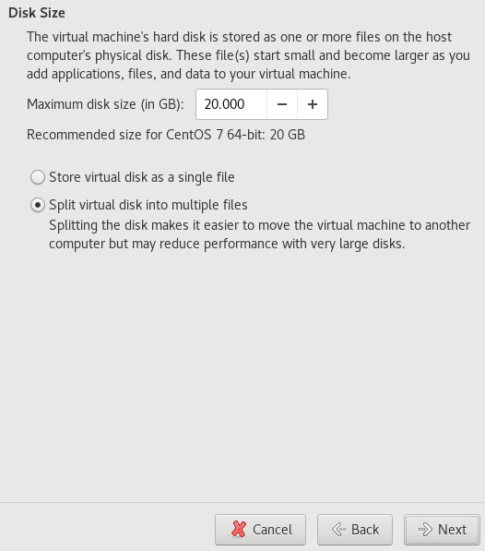

Standard disk size of 20GB

1. 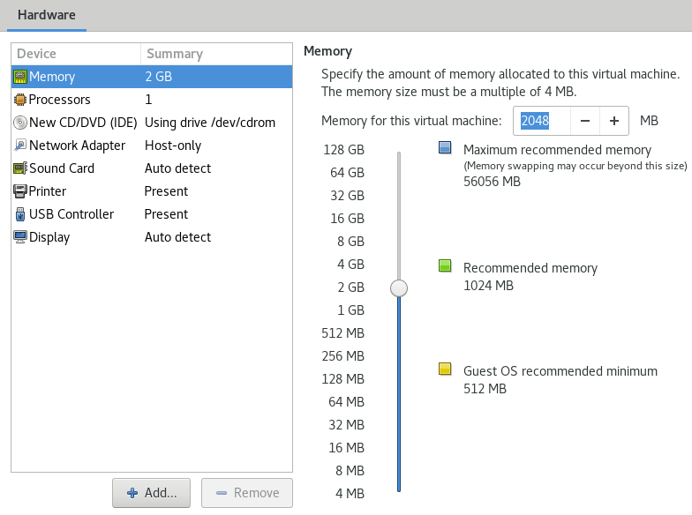

Changed memory allocation to 2GB

1. 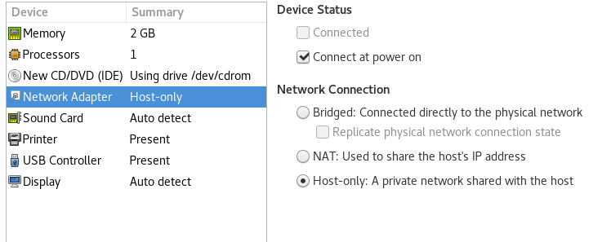

Configured network adapter to Host-Only

1. 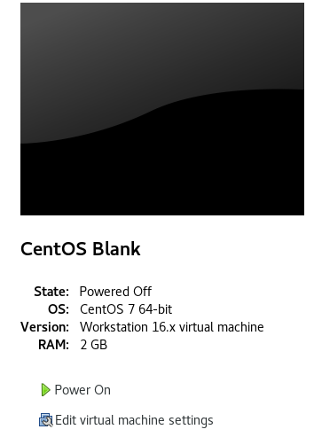

Successfully created blank virtual machine, I later changed the name to kickstart within the settings of the virtual machine.

1. Text

   Description automatically generated

Loaded blank virtual machine showing “Operating system not found”

# Configuring DHCP

Configuration of the DHCP file will allow my hosts to communicate with each other.

## Kickstart Utilities

1. 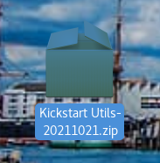

Downloaded kickstart utilities

I first downloaded the kickstart Utils zip, figure 8, which included the configuration files needed to create the kickstart server on the blank CentOS 7 virtual machine.

## Editing dhcpd.conf file

Opening the dhcpd.conf file from the kickstart utils zip, I altered all relevant information to replicate my network structure.

Ens33: 192.168.3.128

Vmnet1: 192.168.137.1

Vmnet8: 172.16.75.1

1. 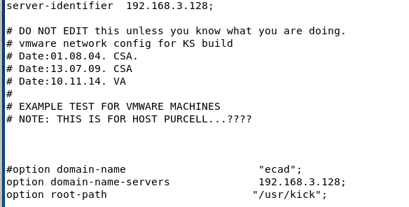

Server-identifier & option domain-name-servers modified

1. 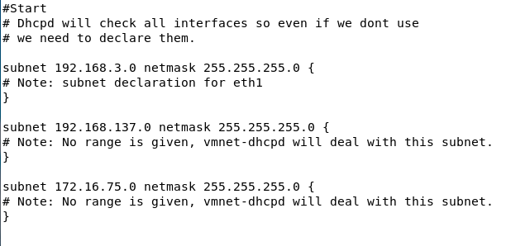

Network adapters modified to match subnets of ens33 and vmnet8

1. 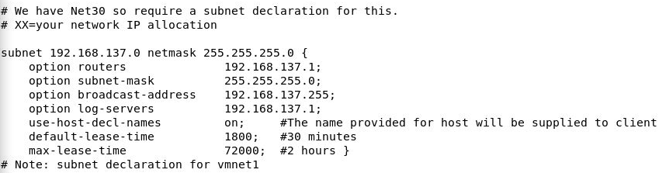

Vmnet1 subnet configured

1. 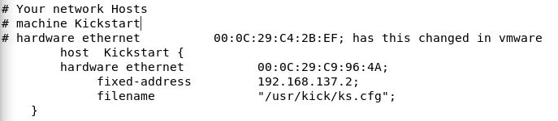

Network information for blank VM configured

Changed mac address and name according to blank machine name and fixed address is the second usable address on the vmnet1 subnet.

1. 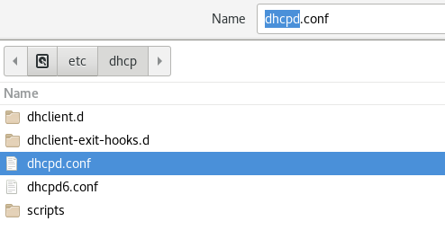

Saving dhcpd.conf file in /etc/dhcp

## Installing DHCP Services

To ensure that dhcp would work correctly, I then installed the dhcp services.

1. 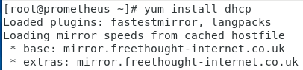

Beginning package installation of dhcp services using yum install dhcp

1. 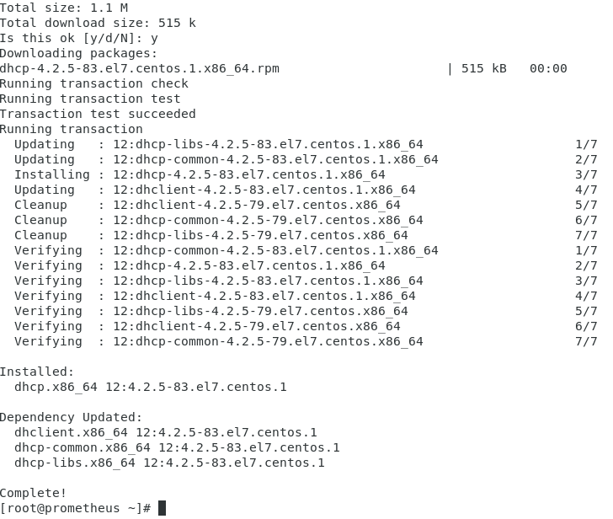

Dhcp services fully installed

1. Table

   Description automatically generated

Displaying all dhcp processes currently running on the system

1. Table

   Description automatically generated

Stopping dhcp process from running on vmnet1 using kill -9 (process number). Once restarted, the changes of the dhcpd file that I created should take effect immediately.

## Testing DHCP

1. 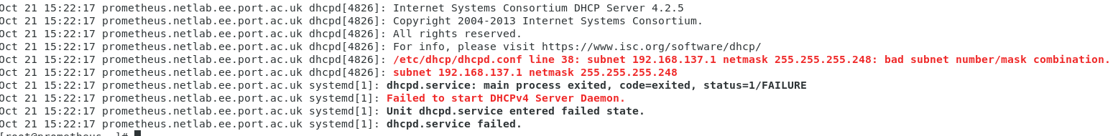

Error when re-starting dhcp service using “service dhcp restart”. Error thrown shows problems with vmnet1 subnet configuration.

1. 

Changed .248 to .0

1. 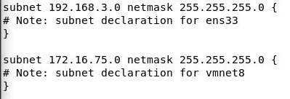

Vmnet1 declaration removal

Whilst doing this, I also removed the double vmnet1 declaration as it is later mentioned with more detail. This means I am left with two smaller declarations, figure 21, for ens33 and vmnet8.

### Second Test

### 

Confirming dhcpd is not running before starting service

1. 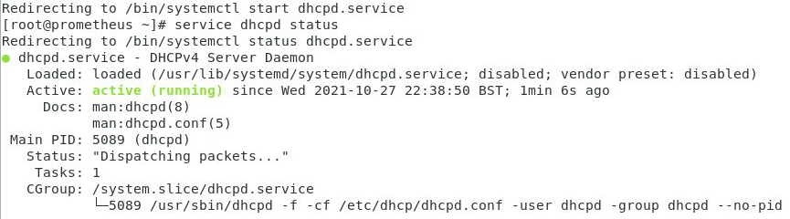

Dhcpd error fixed and now actively running in background

# Configuring NFS

To configure NFS, I will be modifying the exports file from the kickstart zip and creating 2 separate folders, deploy and kick within the mnt and usr directories of the system.

## Export file configuration

1. For the configuration of the exports file, I only need one address for /mnt/deploy and /usr/kick. These will use the vmnet1 address 192.168.137.0 with a 255.255.255.0 subnet mask.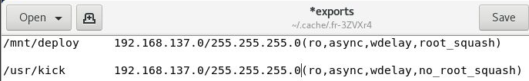

Removed extra declarations from export file and modified to match vmnet1 ip address

1. 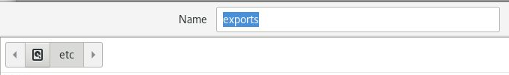

Saving exports.conf in etc directory

1. 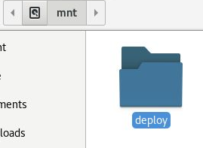

/mnt/deploy(createfolder)

The folder deploy in /mnt is the folder I will use to store the contents of the CentOS 7 iso. This is the location the kickstart server will have access to and install from.

1. 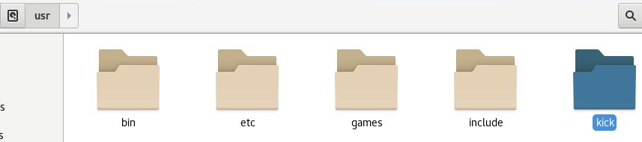

/usr/kick(createfolder)

The folder kick in /usr is where the kickstart configuration files will be stored

## Testing configuration

1. 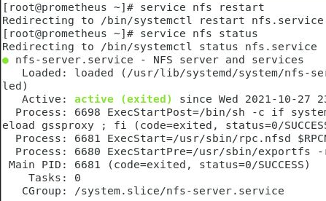

Service nfs restart

Using the service nfs restart command, the service immediately begun running in the background showing that the exports file was configured correctly.

1. 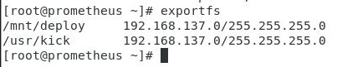

Exportfs

To check that the export file is running correctly, typing exportfs into the terminal shows the current configuration for the folders the service is using and the ip address in relation to them. As shown in figure 29, the nfs service is setup correctly and using the correct configuration.

# Installing and Configuring Kickstart

Kickstart will be used to create the configuration file for the CentOS 7 install on the blank virtual machine. Using the kickstart gui, I will configure settings and packages required.

## Installation

1. 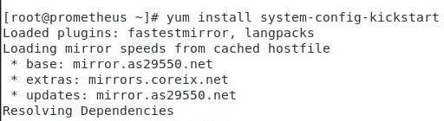

Beginning the installation of the kickstart package using “yum install system-config-kickstart”

### Editing ks.config

Installing kickstart onto the server, typing system-config-kickstart will open the gui to create the ks.config file where all settings for the kickstart server can be setup.

1. Graphical user interface, text, application, email

   Description automatically generated

Modifying language, time zone, and setting password to “localhost1”

1. 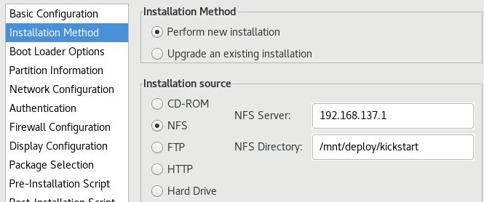

Editing installation method to perform new installation and setting source to NFS server previously created

1. Graphical user interface, text, application, email

   Description automatically generated

Configuring kickstart to install a new bootloader. Without this configured the installation will not carry out as intended.

1. Table

   Description automatically generated

Storage layout configuration with root (/) directory which expands as needed

1. Graphical user interface, application

   Description automatically generated

Creating a network card to match server’s ens33

1. 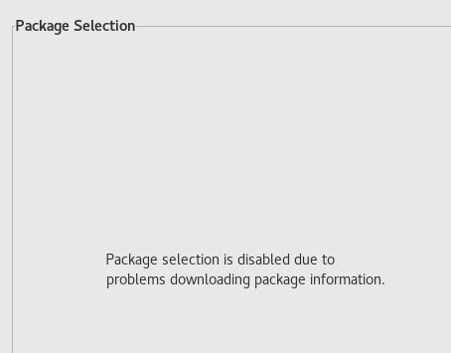

Common package selection problem where package selection is disabled

As can be seen in figure 32, no packages can be selected, this is a common problem with the kickstart gui where there is a problem with the code, to fix this I will have to implement a simple package selection fix.

## Implementing package selection fix

1. 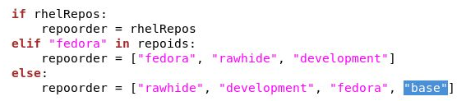

Adding “Base” at line 164 of packages.py

In a terminal typing gedit /user/share/system-config-kickstart/packages.py will open the python file for the packages section of the configurator. At line 164 I then added “base” at the end of the else: statement. This should then fix the package selection section of the gui.

## Kickstart Configuration continued

1. Graphical user interface, application

   Description automatically generated

Package selection now fixed and able to selection relevant packages for install

1. Graphical user interface, application

   Description automatically generated

Saving ks.cfg within the previously created /usr/kick folder

1. 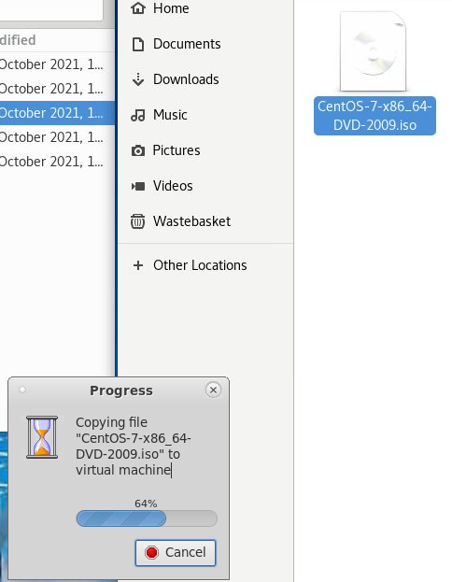

Copying CentOS from host machine to server.

1. 

Pointing the blank virtual machine to the iso file stored on the server

After copying over the iso, I then pointed the virtual blank virtual machine to this iso so the kickstart server will begin the installation of CentOS.

Testing Server

1. 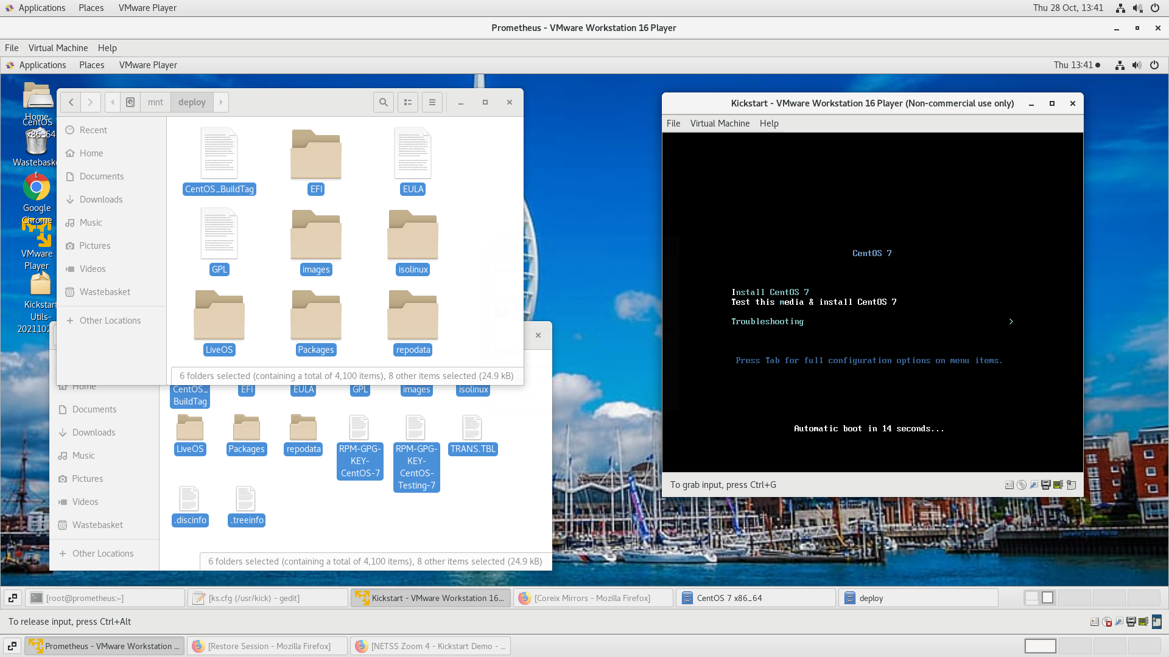

Copied files from iso to /mnt/deploy and successful boot of CentOS 7 install

I copied over the files from the iso to /mnt/deploy as this is where the kickstart file will look for installation media since it has been set to use NFS. Once the install screen for CentOS 7 appeared, rather than pressing enter which would take me through the standard procedure, I pressed tab which pauses this menu and allows me to enter a custom command.

1. 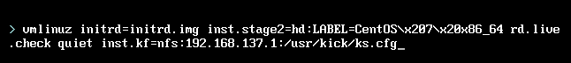

inst.ks=nfs:192.168.137.1:/usr/kick/ks.cfg

Entering the command “inst.ks=nfs:192.168.137.1:/usr/kick/ks.cfg” at the end of this line points the installation towards the kickstart configuration file that I previously created through the nfs server. This will give the installation access to what packages and settings are needed as they are already declared in the ks.config file.

1. 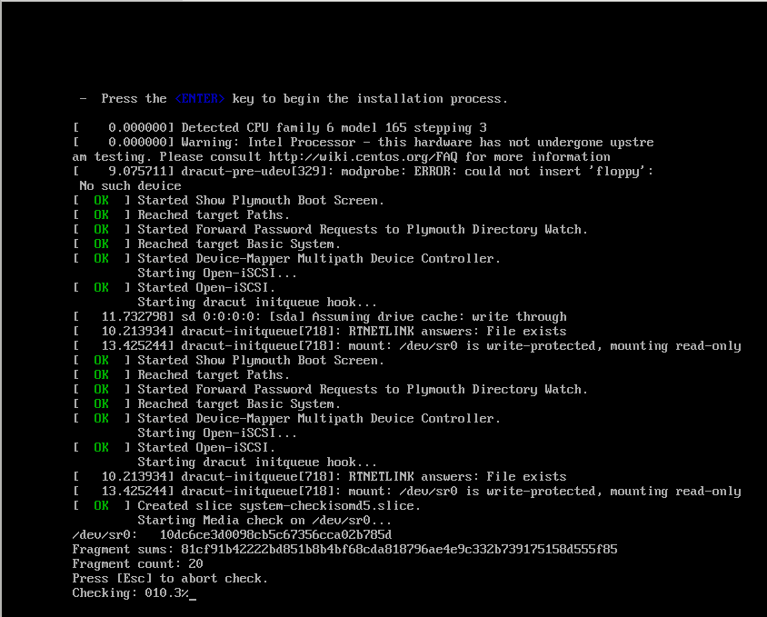

Beginning the CentOS installation process on kickstart server

1. Graphical user interface, application

   Description automatically generated

The installation did not follow through properly. When installing via nfs using kickstart, this should be autonomous as all settings and packages are all pre-defined within the ks.config file.

## Fixing NFS boot error

1. 

When double checking the network settings, I could not see any problems with the network configuration. The gateway is set as the address for the nfs server and the IP which is to be used for the kickstart server is set as the second addressable host on the vmnet1 subnet.

1. Graphical user interface, text, application, email

   Description automatically generated

Moving back into the kickstart configurator, I changed install type to “Install new boot loader”. Previously this was set to “Do not install”, without this configured the installation will not carry out as intended.

1. Text

   Description automatically generated
2. 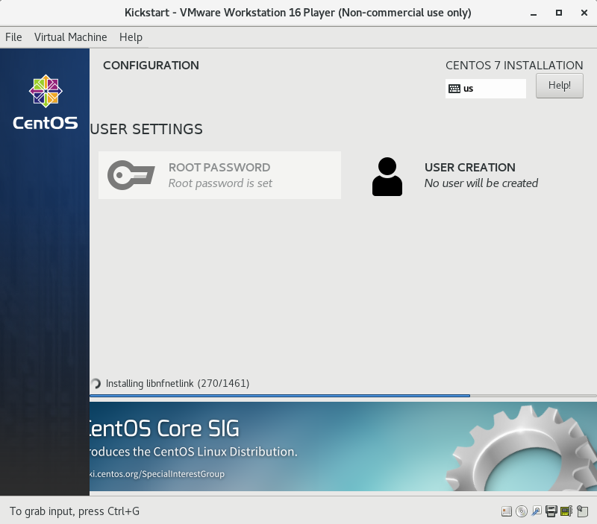

After reconfiguring the bootloader setting and the command used to run the ks.config file via the nfs server, the installation process continued as expected

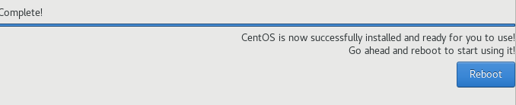

1. CentOS 7 completed automatic installation after error fix in config file

1. CentOS 7 installed on kickstart server and login screen showing correctly

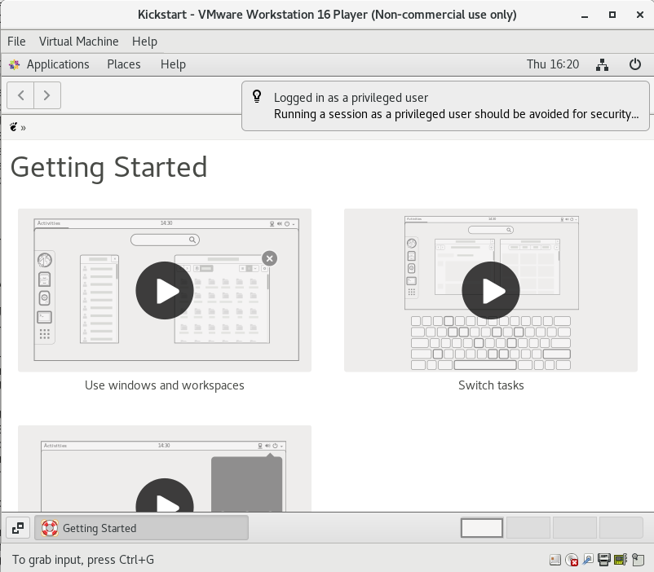

1. Logged into kickstart server using pre-defined password from ks.config setup

# 

# Installing and Configuring LDAP

### Network Table

|  |  |  |
| --- | --- | --- |
| Hostname | IP Address | Purpose |
| Prometheus.netlab.ee.port.ac.uk | 192.168.137.1 | LDAP SERVER |
| Kickstart.netlab.ee.port.ac.uk | 192.168.137.2 | LDAP CLIENT |

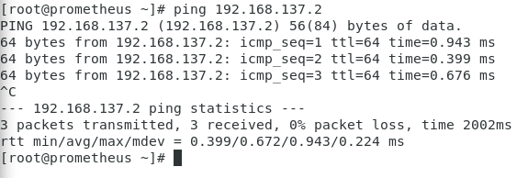

1. Ping Kickstart Server from Prometheus

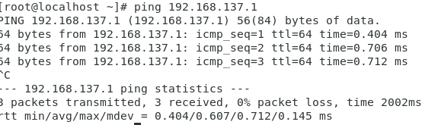

1. Ping Prometheus from Kickstart Server

## Configuring /etc/hosts file



1. Act like a dns, gives the ability to ping via name

### Editing /etc/hosts

Prometheus

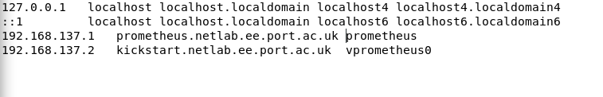

Kickstart Server

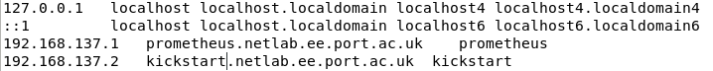

### Testing

Ping “prometheus”

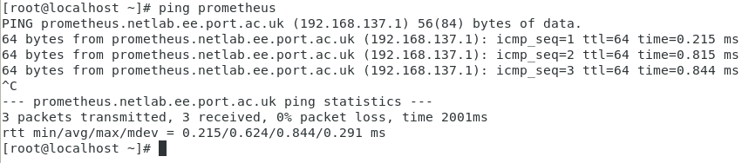

Ping “kickstart”

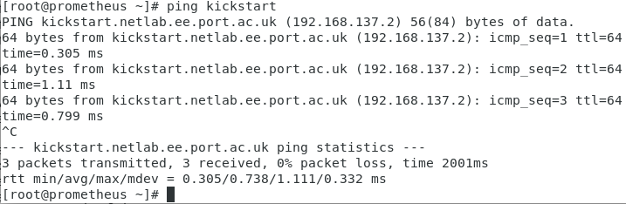

## LDAP Installation

### Installing LDAP Packages



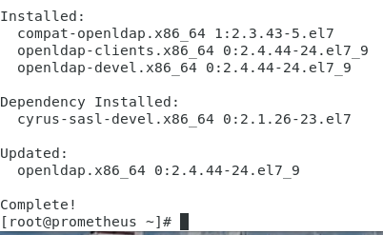

### Starting LDAP Service & Enabling Auto Start



### LDAP Verification

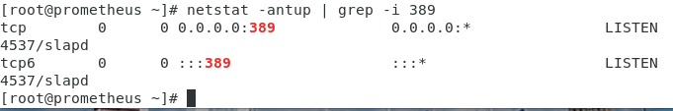

## LDAP Admin Setup

### Configuring Admin Password



## 

## OpenLDAP Server

Encrypted password: rw5OUJjFPePUuOQtMAAOMYn5wMEqLv+o

olcSuffix –Database Suffix, it is the domain name for which the LDAP server providesthe information. In simple words, it should be changed to your domain name.•olcRootDN –Root DistinguishedName (DN) entry for the user who has the unrestrictedaccess to perform all administration activities on LDAP, like a root user.•olcRootPW –LDAP admin password for the above RootDN.

### Creating db.ldif file

Reason for using vi: Creates cleanest files and is the best when trying to eliminate control characters.

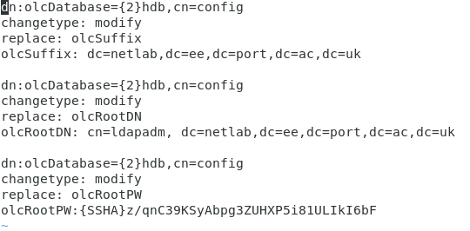

### Testing

#### 

### Monitor.ldif

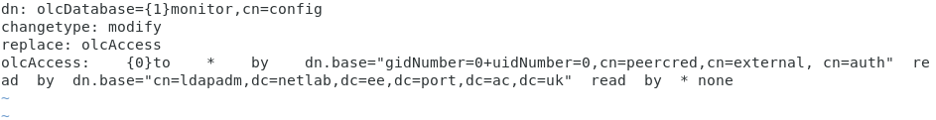

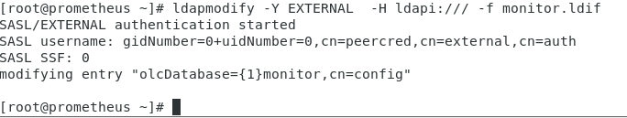

## Setting up LDAP Database

Copy the sample database configuration file to /var/lib/ldap and update the file permission



Add the cosine and nis LDAP schemas

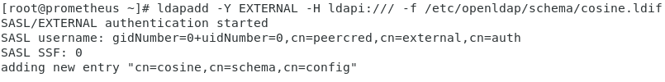

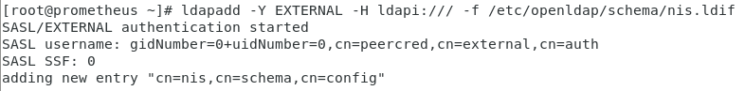

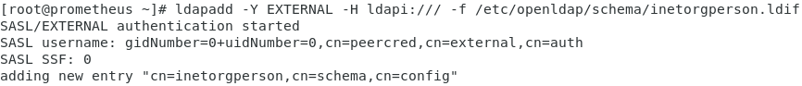

Generate the base.ldif file for your domain

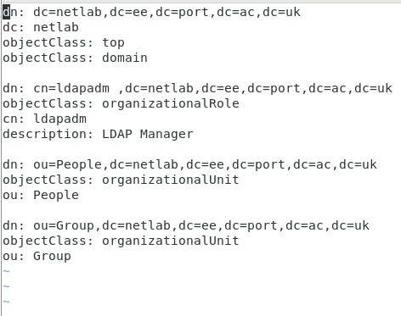

Building LDAP Directory Structure

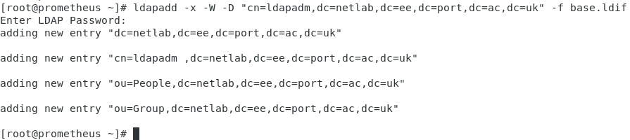

Figure 1 Selected install operating system later 1